**Waterfall model**

Waterfall approach was first SDLC Model to be used widely in Software Engineering to ensure success of the project.

Following is a diagrammatic representation of different phases of waterfall model.

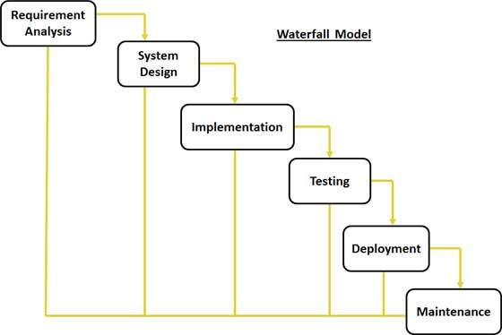

* **Requirement Gathering and analysis:** All possible requirements of the system to be developed are captured in this phase and documented in a requirement specification document.
* **System Design:** The requirement specifications from first phase are studied in this phase and system design is prepared. System Design helps in specifying hardware and system requirements and also helps in defining overall system architecture.
* **Implementation:** With inputs from system design, the system is first developed in small programs called units, which are integrated in the next phase. Each unit is developed and tested for its functionality which is referred to as Unit Testing.
* **Integration and Testing:** All the units developed in the implementation phase are integrated into a system after testing of each unit. Post integration the entire system is tested for any faults and failures.
* **Integration and Testing:** All the units developed in the implementation phase are integrated into a system after testing of each unit. Post integration the entire system is tested for any faults and failures.
* **Integration and Testing:** All the units developed in the implementation phase are integrated into a system after testing of each unit. Post integration the entire system is tested for any faults and failures.
* **Deployment of system:** Once the functional and nonfunctional testing is done, the product is deployed in the customer environment or released into the market.
* **Maintenance:** There are some issues which come up in the client environment. To fix those issues patches are released. Also to enhance the product some better versions are released. Maintenance is done to deliver these changes in the customer environment.

**Application**

Every software developed is different and requires a suitable SDLC approach to be followed based on the internal and external factors. Some situations where the use of Waterfall model is most appropriate are:

* Requirements are very well documented, clear and fixed.
* Product definition is stable.
* Technology is understood and is not dynamic.
* There are no ambiguous requirements.
* Ample resources with required expertise are available to support the product.
* The project is short.

**Advantages and Disadvantages:**

**Advantages**

* The advantage of waterfall development is that it allows for departmentalization and control. A schedule can be set with deadlines for each stage of development and a product can proceed through the development process model phases one by one.
* Development moves from concept, through design, implementation, testing, installation, troubleshooting, and ends up at operation and maintenance. Each phase of development proceeds in strict order.

**Disadvantages**

* The disadvantage of waterfall development is that it does not allow for much reflection or revision. Once an application is in the testing stage, it is very difficult to go back and change something that was not well-documented or thought upon in the concept stage.